**Movie Ticket Booking system**

Group 8

Samaya Bhari, Suprima Pote Shrestha,

Sanskriti Parajuli, Sudeep Thapa

1. Introduction

Our group has decided to create an information system for different franchises of our movie theater. With the pandemic slowing down, people coming to movie theaters have increased. With the clients looking for safe options to buy their tickets and the company working to manage all data to quantify the customer's preferences, we have decided to design this system to help us understand the priorities and manage them seamlessly.

1. System Request
   * 1. Project Sponsor:
        1. Our Sponsor for this project will be the Chief Technology Officer of our theater.
     2. Business Need:
        1. After the COVID-19 pandemic and evolving technology, customers have been looking for safer and easier options to buy/make reservations for movie tickets. Therefore, we are willing to build a system that helps our customers make reservations for their movie tickets online. This will help our customers in terms of their safety, convenience, and business to keep track of customer data in the database.
     3. Business Requirement:

To satisfy the needs of our customers and manage our database, we will develop a system that will assist us in achieving the following:

* + - 1. The system will allow users to make payments, modify, and cancel their reservations online.
      2. The system will provide refunds to the customers who cancel their reservation before the showtime.
      3. The system manages its database for customer database and proved them loyalty points based on the loyalty program database
      4. The system will match the types of movies based on their preferences
      5. The system will store customers' information in the database, which users can log in to at any time and get enrolled in an automatic loyalty program.
    1. Business value: This system will let the users conveniently book their tickets online, which will not only help to increase customer satisfaction, but will also help to broaden the horizon.
    2. Special Issues: If the page refreshes on its own, the user has to login back in and book the seats again. Multiple users can choose the same seat but only one user can get it. If there is a newly released movie, then the site might crash due to overload of the users.

1. Technical Feasibility:
   1. Although the system we build will be different from the traditional ticket buying system on the counters, the interface of our system will be very straightforward and simple. The users will be able to book their tickets even if it is their first time using the system. The new system is perfectly compatible with the existing systems so the transition to a new system would be seamless.
2. Economic Feasibility:

We have performed economic feasibility by forecasting the costs and benefits of our

system for over five years. The Cost-Benefit analysis or the economic feasibility helps us to identify the financial risks of building the system by analyzing the development costs, operational cost, benefits and determining the cash flow for five years, Net present value (NPV) and the Return on Investment (ROI) of our system. For our revenues and cost saving, we have included tangible benefits such as Increased sales, Reduction in staffs and intangible benefit, Customer loyalty. We have predicted our growth rate to be at 4% following the current economy and the ongoing pandemic situation. Our tangible expenses include the development costs such as software licenses, development labor, and operational costs such as hardware, software, operational labor. The costs are estimated to be a total of 10,36,483 by the end of year 5. Our estimated Return on Investment (ROI) after five years is 20.69%. We found our Break-even point occurring in year 3, identifying the year in which our benefits are larger than the costs reaching a positive cash flow.

As per our intangible benefits we have predicted that we will have increased preferences in comparison to our competitors because of our improved and user-friendly interface leading to increased customer satisfaction and in turn strengthened customer loyalty.

The economic feasibility and the break-even graph will be submitted in two different excel spreadsheets.

1. Organizational Feasibility:
   1. Having a strategy that aligns perfectly with the business strategy and business needs is very important when we talk about the organizational feasibility. Since our company values the convenience of the customers, we strive to make sure that our clients get the best of all facilities and less stress over these things. The sales department can be the stakeholder of the system as their jobs will have significant change over the implementation of the system.
2. Functional Requirement
   1. Manage the Loyalty Program and Member database
   2. Customers get to login using their phone number and their credentials.
   3. Customer sets their preferred cards for the payments (credit, debit)
   4. Customers get to use their promo code and loyalty rewards.
   5. System will recommend promotional offers like buy one get another half off based on their logins.
   6. Make booking reservation
   7. Customers streams the website and select the movie and showtime they want to book
   8. System checks the credentials of customers and determine if it is an existing account or new account
   9. Customer gets to add any promo code and proceed for payment
   10. Both customer and the system should be able to have booking confirmation via email/ text message and booking database respectively.
   11. Cancel an existing reservation
   12. Customers log in to their profile through their credentials
   13. Customers modify their reservation from their account, through cancel reservation button
   14. System updates the seats and movies available online and updates the database
   15. Customers get their refund back on their default card.
3. Non-Functional Requirement
   1. Operational Requirement:
   2. The system should operate in both MacOS and Windows (platform independent)
   3. The site should be able to handle multiple booking requests simultaneously.
   4. The system should choose the right time zone.
   5. Reservations database and Loyalty program member database
   6. Performance requirement:
   7. The system should be able to connect to the database with the use of the credential within a few seconds.
   8. There should not be a conflict between two user books at the same period.
   9. Security requirement:
   10. The system should visually confirm as well as send booking confirmation to user email.
   11. The system should keep their user privacy safe.
   12. Two factor authentication (email or phone number)
   13. Cultural and Political Requirements
   14. No special cultural and political requirements are anticipated.
   15. **Use- Case Diagram:**

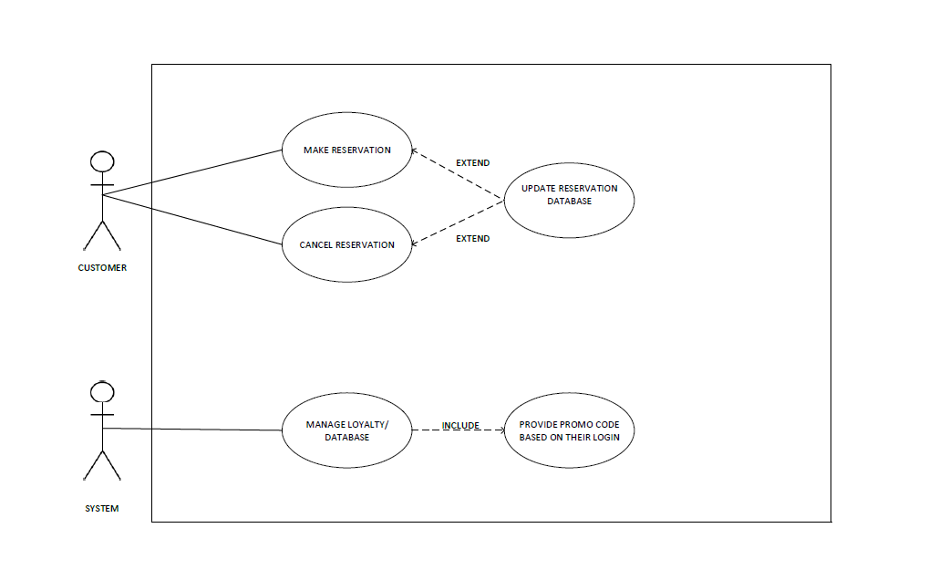

1. **Activity Diagram:**

Diagram1:

Diagram 2:

Diagram 3:

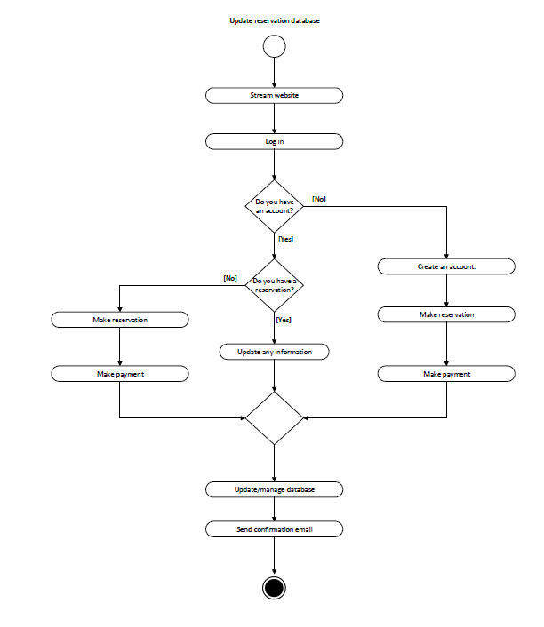

Diagram 4:

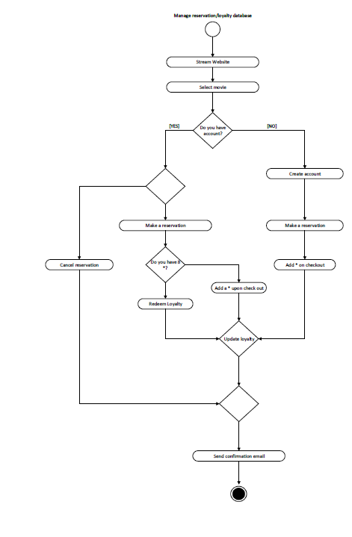

**d. Use Case Description for:**

* + - * 1. Activity Diagram 1:

Activity diagram 2:

Activity diagram 3:

Activity Diagram 4:

**e. CRC Card for each class**

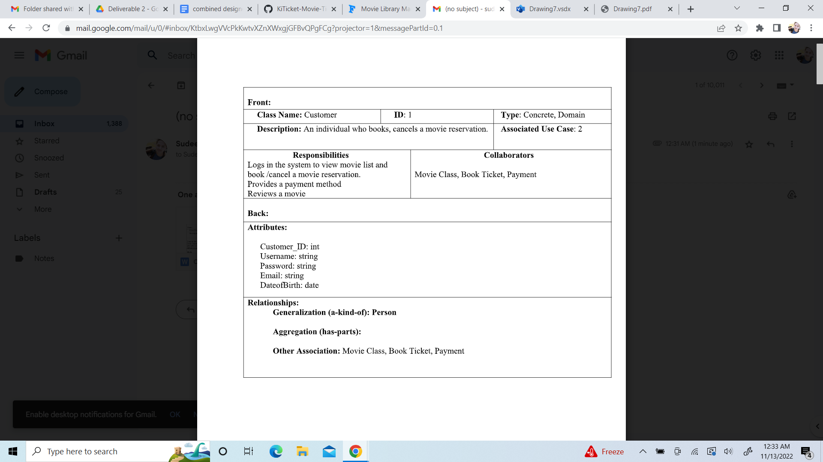

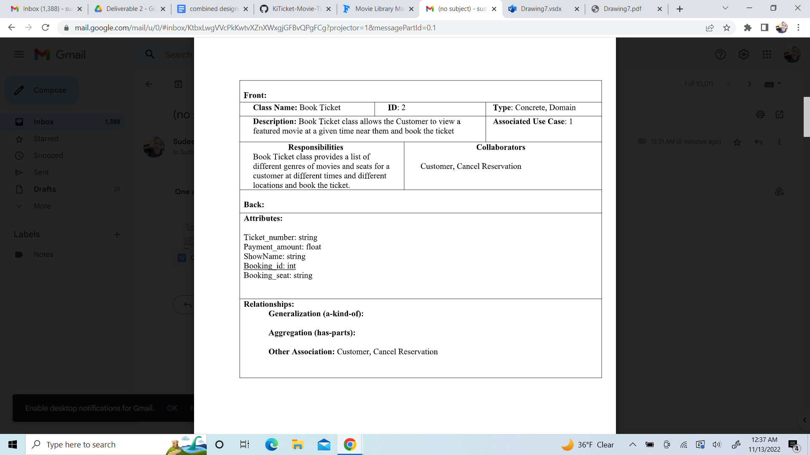

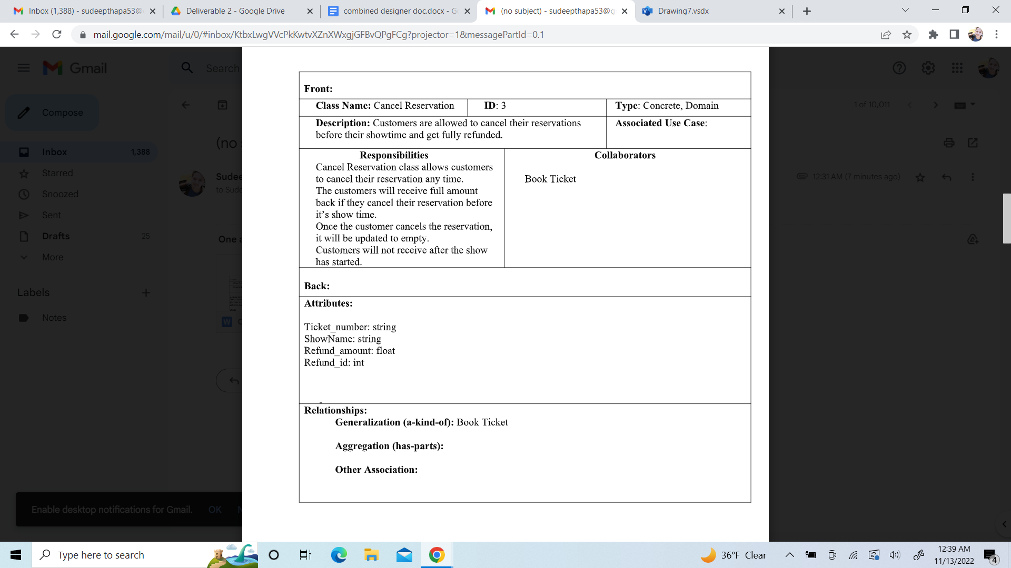

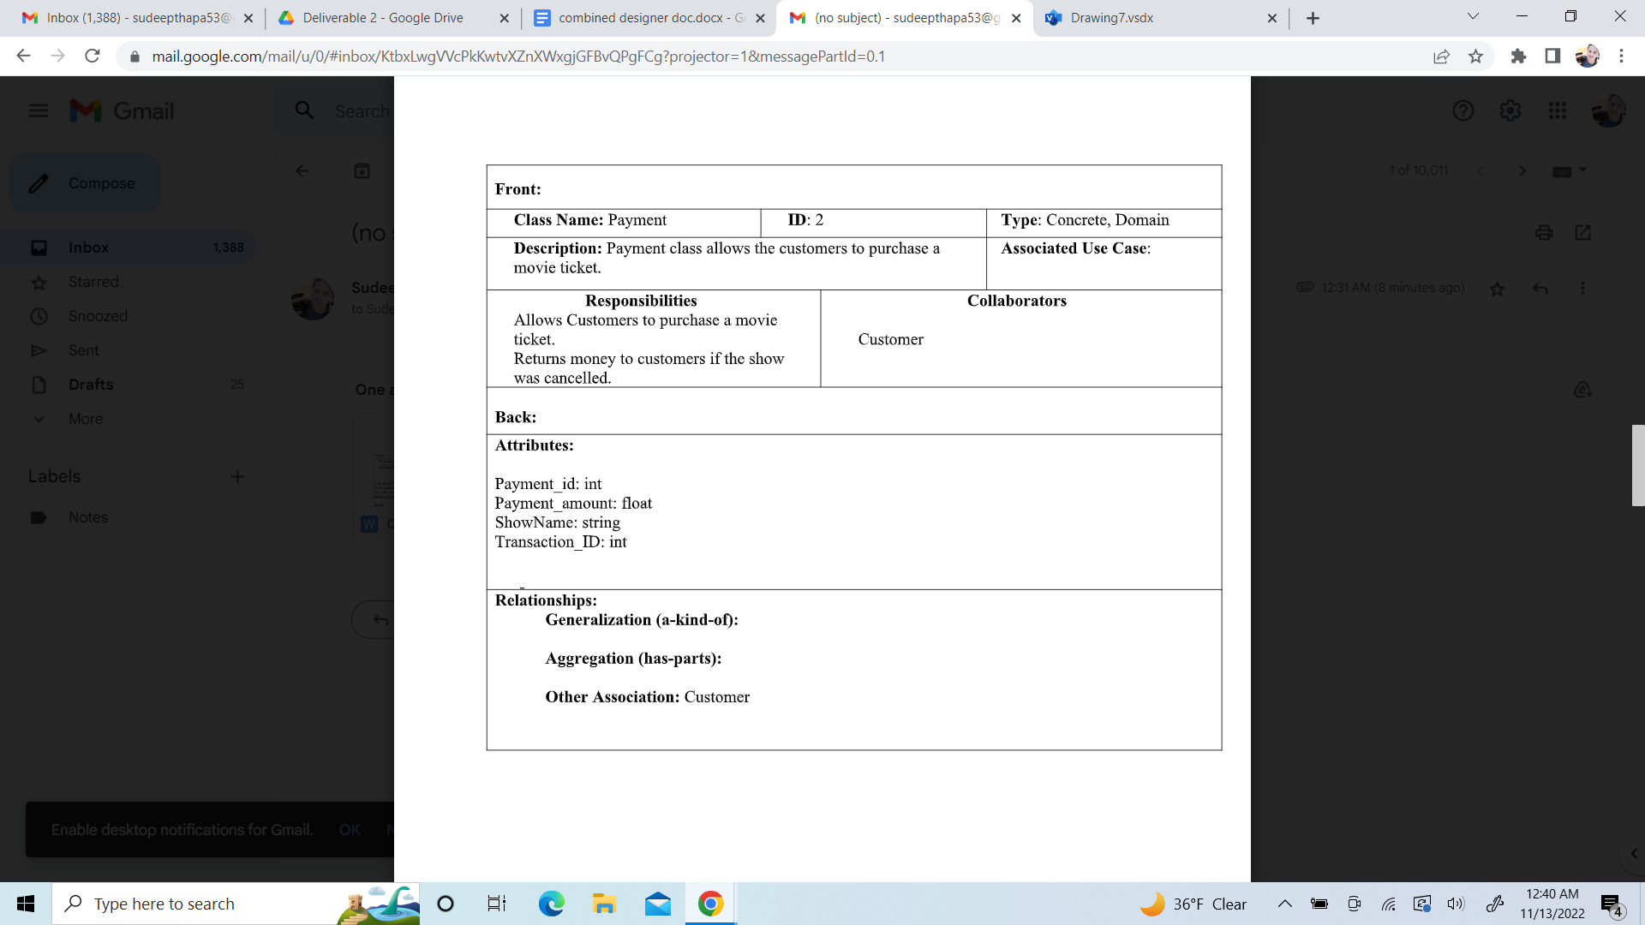

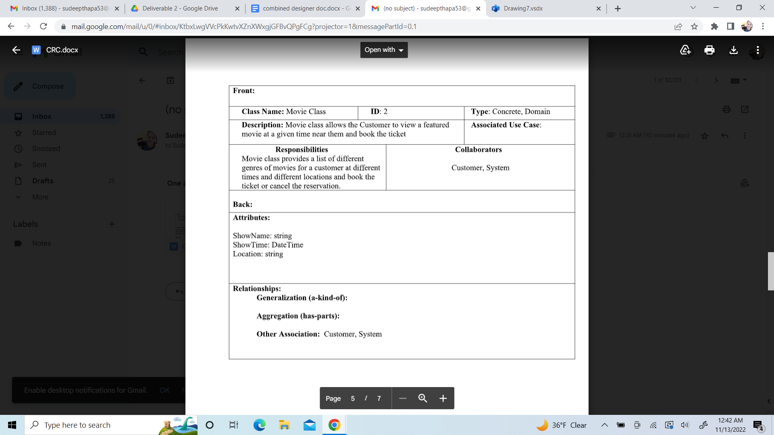

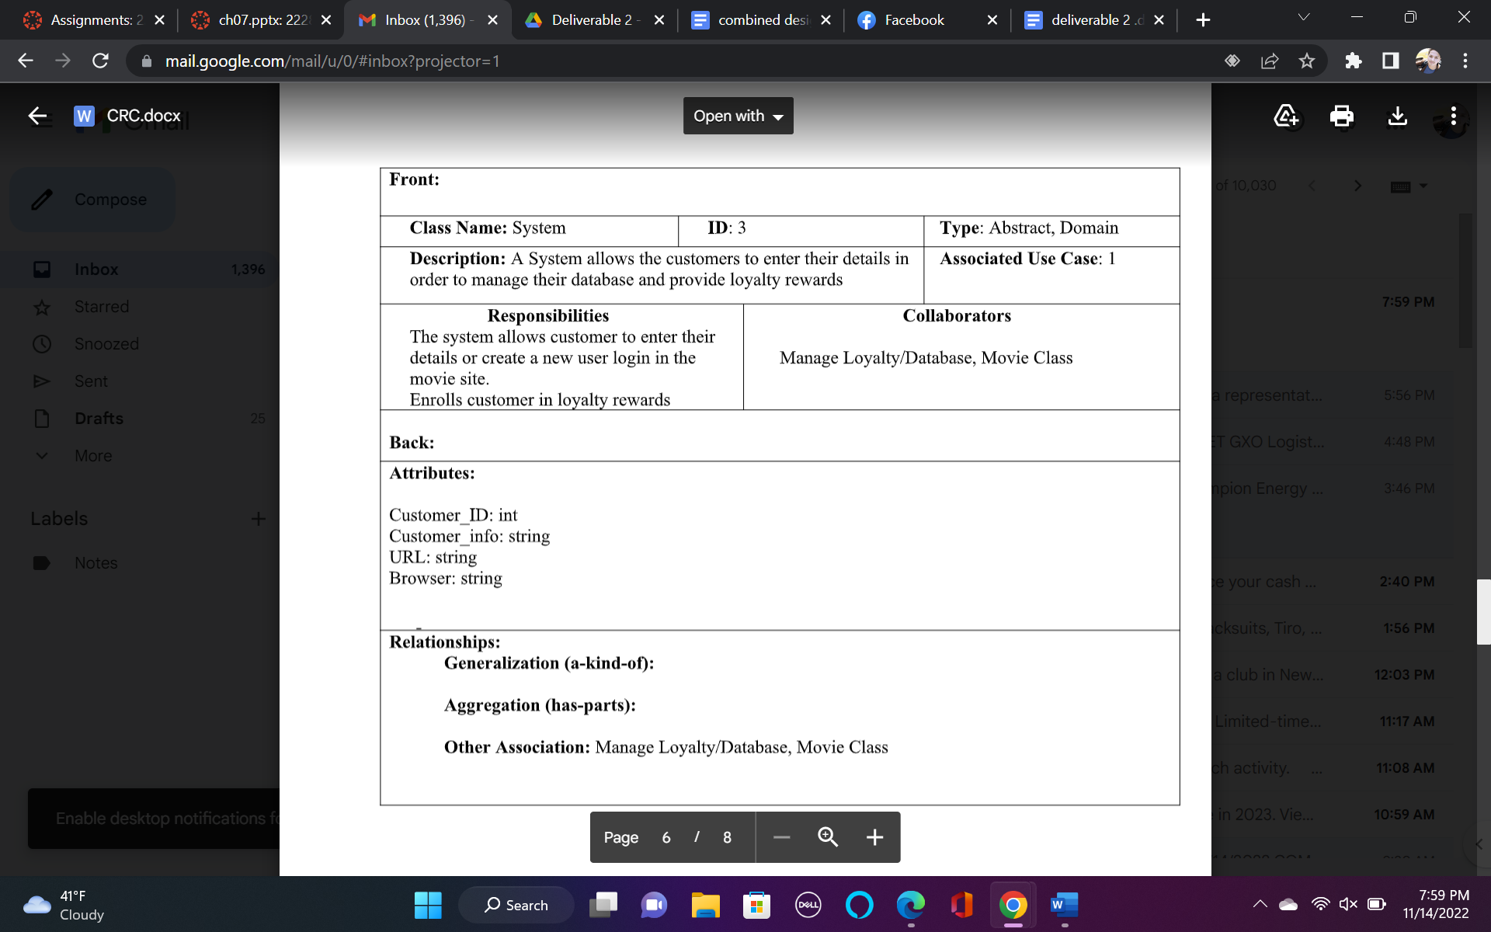

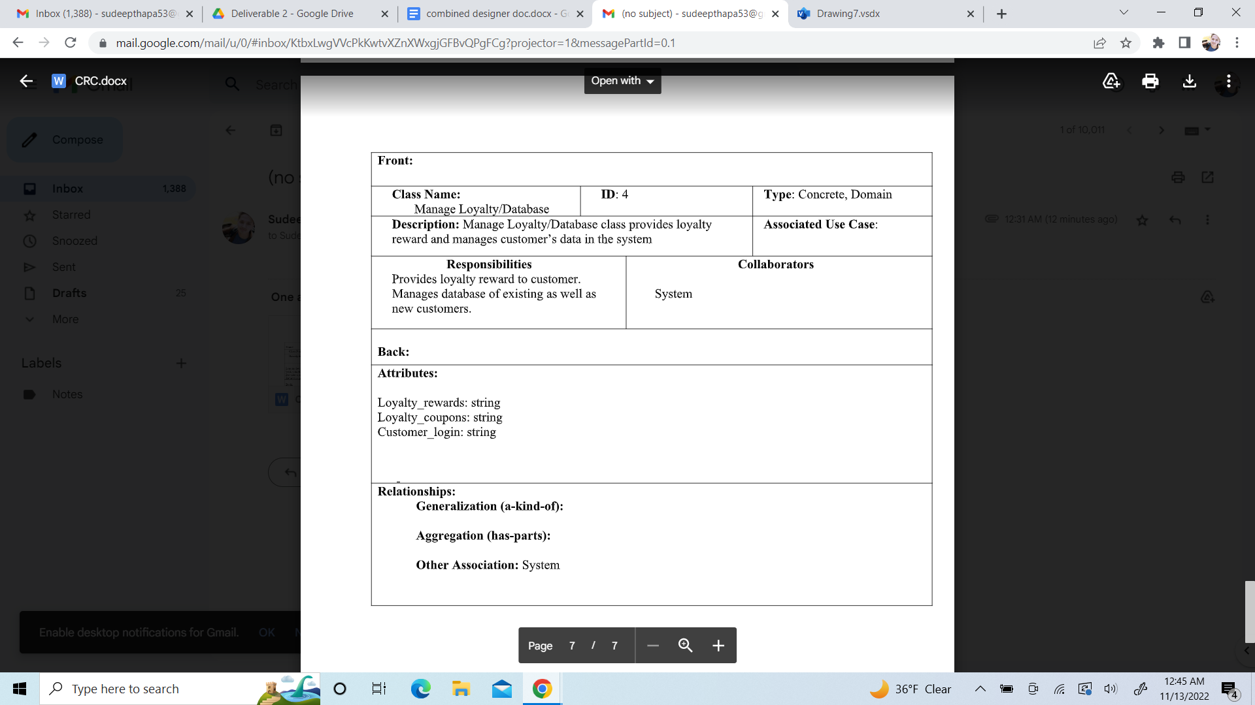

**Class Diagram**

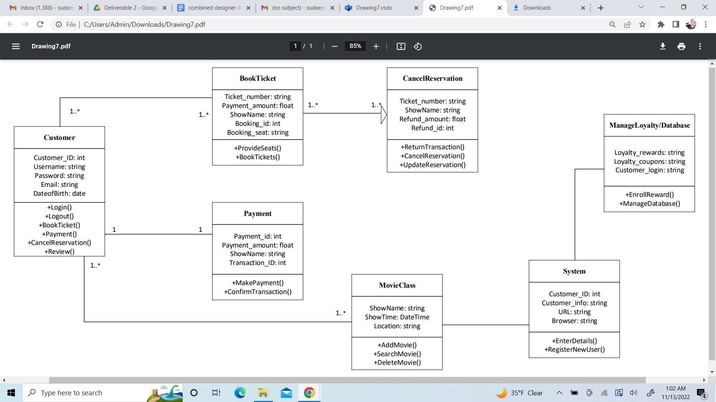

Sequence Diagram:

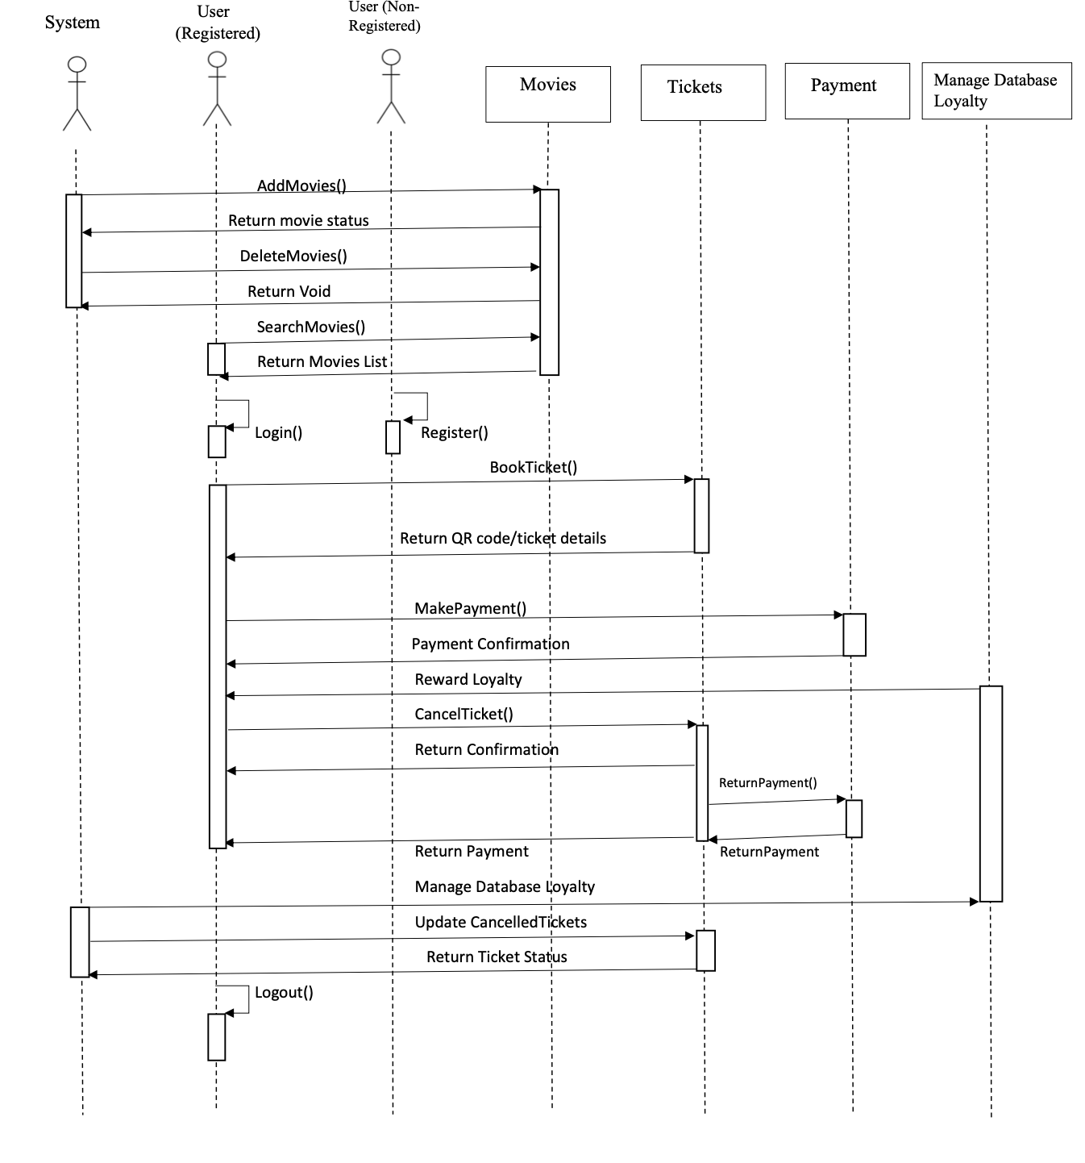

Communication Diagram:

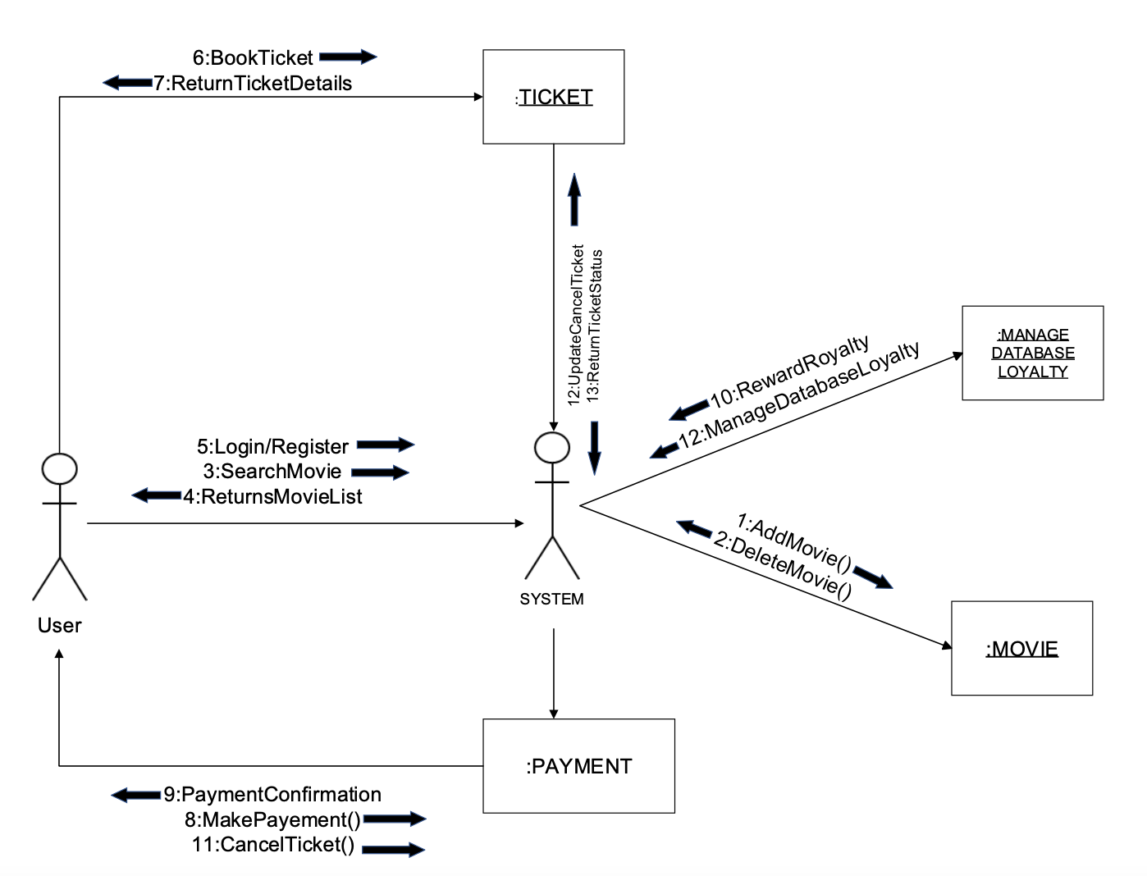

Behavioral State Machine Diagram: 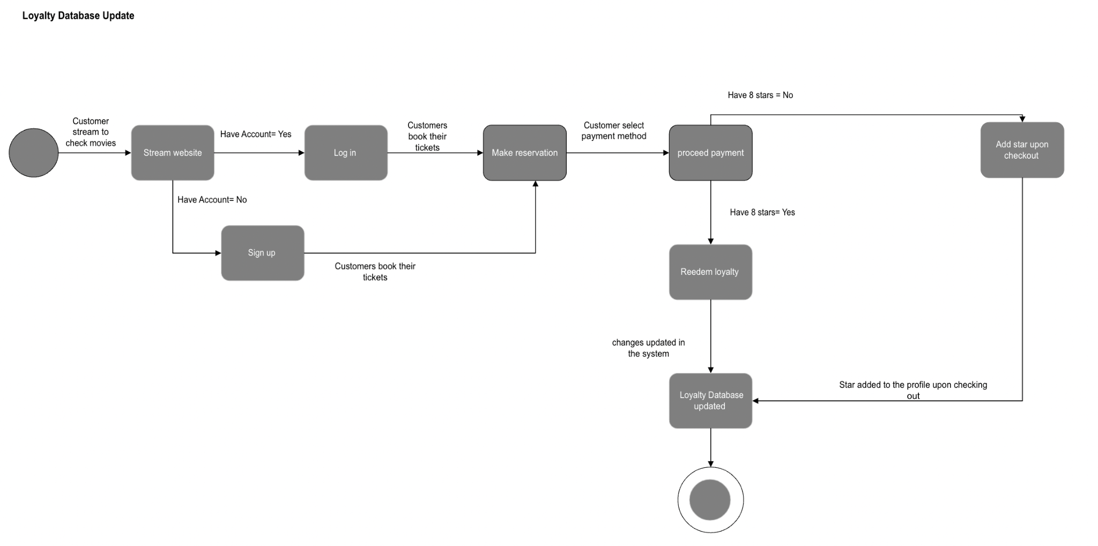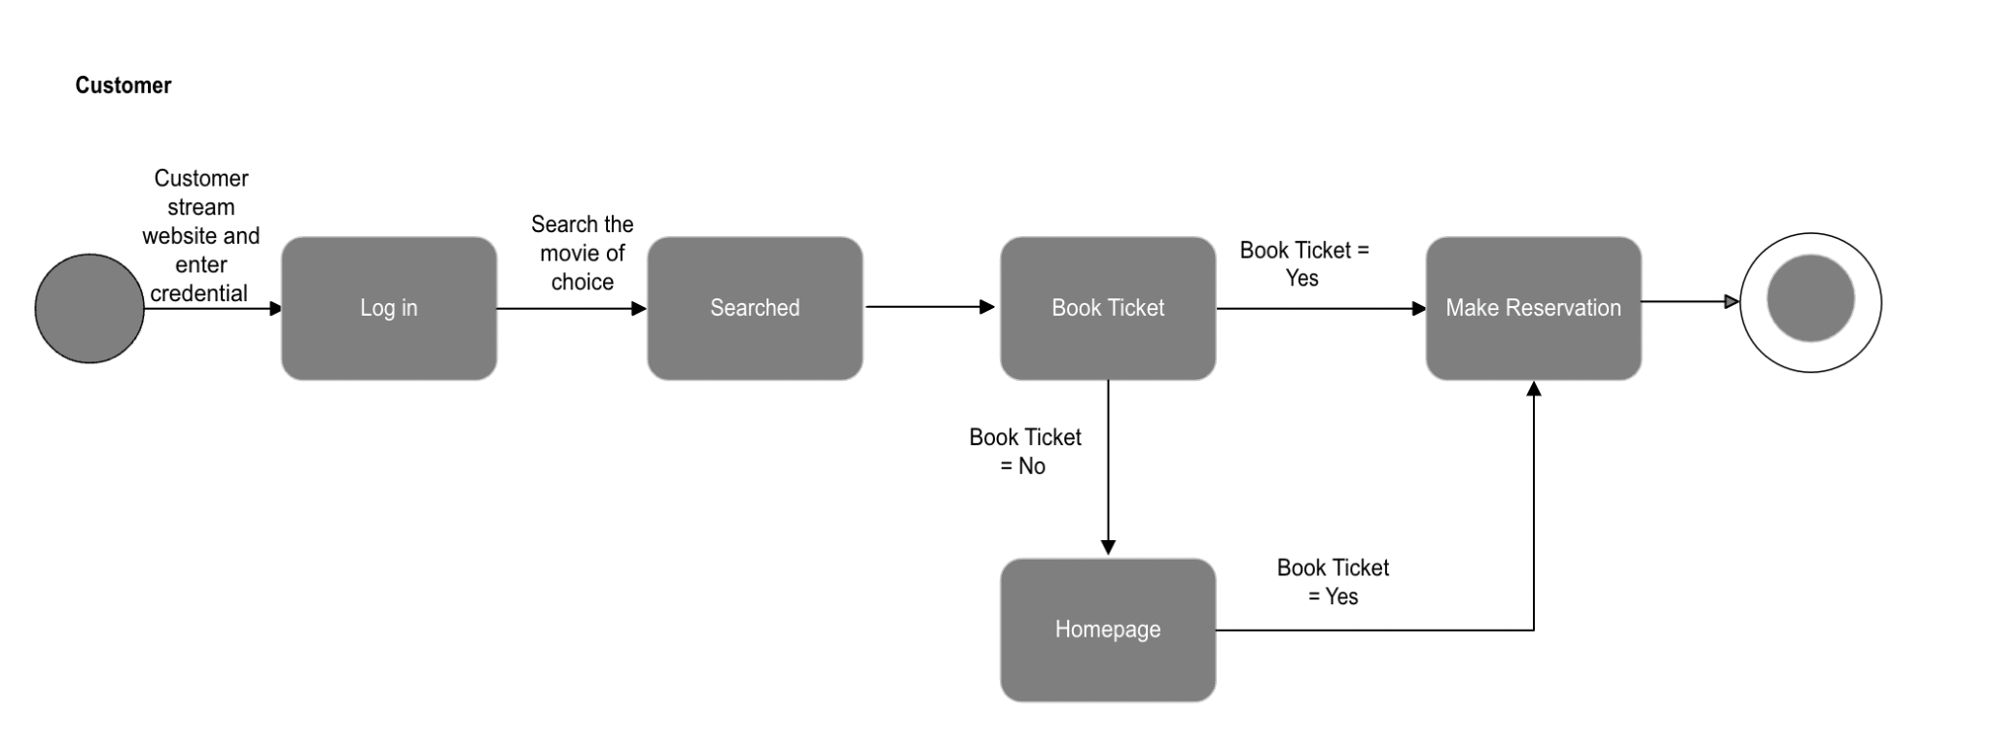

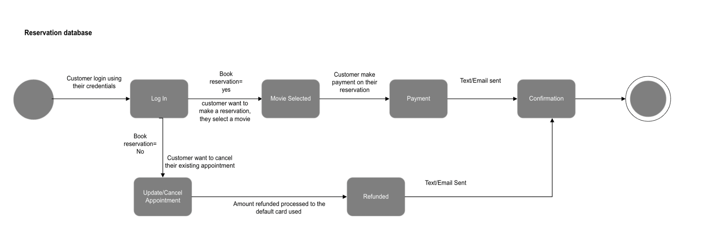

**Action On Recommendation**

1. Our group was very great in collaborating and communicating with their team members throughout this project. Every critique that we gave to our partner user group and received from our partner designer group were carefully analyzed.
2. We were able to make some corrections in our communication and sequence diagram in the final deliverable by the help of some constructive comments from Group 10. Likewise, me and my group were also able to provide some great insights to our partner user group in theirs however they didn't have much to rework on.
3. Every document that was shared between the user and designer group was very clear this time.